(Appendix B)
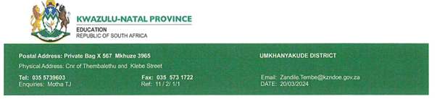
29 February 2024
Dear Miss HT Zwane
PERMISSION TO CONDUCT THE RESEARCH AT NKOMBOSE HIGH SCHOOL

Kindly receive the response to your application to conduct the research entitled as Evaluating perceptions and implications of teenage pregnancies in a rural school within uMkhanyakude District, KZN, SA. Your application has been granted. The conditions of the approval are as follows:

- The researcher will make all the arrangement concerning the interviews.
- The researcher will ensure that teaching and learning is not interrupted and that interviews are conducted outside teaching and learning time.
- Participants will not be identifiable in anyway from the results and the findings of the research.
- A copy of the letter is explaining the purpose of the research will be presented to participants prior to interviews.
- The period of the research will be limited to 4 months only.
- The research will be limited to your proposed participants (teaching staff, non-teaching staff, parents, SGB members, traditional leaders, union representatives, and former learner).
- For any communication, the contact person is Mabatho @ 0737333209.
- Upon completion of your research a summary of your research findings and your research recommendations must be shared with the school community.
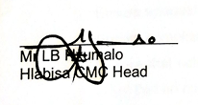
082 268 6814 /072 142 1811

